Samantha Montalvo

10/17/2020

Levkoff

ECON-494

**Video Games Sales Data**

**Section I**

In this assignment my data collection process began with me choosing a topic of interest and framing the problem that I sought to answer. I decided on searching for video game data in order to perform exploratory analysis and eventually predict what type of video game might lead to greater sales. After searching on multiple websites, I found a promising set posted on the data science website, Kaggle. The data set consists of a list of video games with sales greater than 100,000 copies. The qualitative variables include name, platform, genre, and publisher. The continuous qualitative variables include sales in North America (NA_Sales), sales in Europe (EU_Sales), sales in Japan (JP_Sales), sales in the rest of the world (Other_Sales), and total worldwide sales (Global_Sales). Lastly, the set contains one ordinal variable: rank. To begin the analysis, I downloaded the data set and imported into R Studio as a string function using “read.csv” and an assignment operator: the original data set had been named “df”.



Before deciding what steps to take in regard to either cleaning and transforming, I wanted to explore various attributes through preliminary analysis and observation of the raw set. Using the view function, R studio will show the data in spreadsheet format in a separate window. The set contains 16,598 observations and 10 variables as mentioned previously. The structure of the data set is panel since each observation has its own cross section for a particular year.

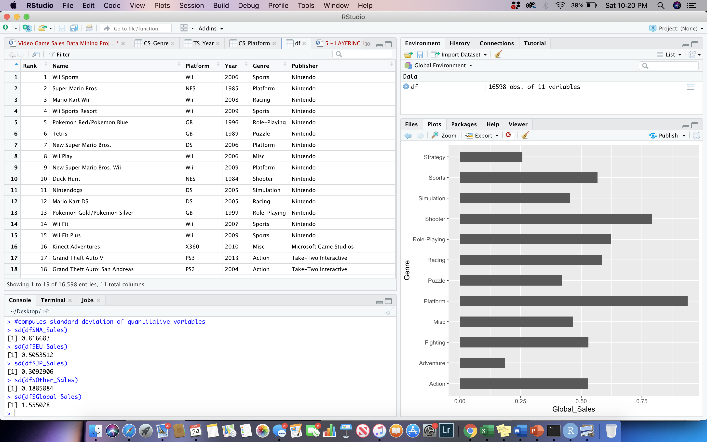

Next I wanted to check the object class of the data frame and explore a summary statistical table to gain a greater understanding of the variables. What can be first noticed in table is that the means of North America Sales, Europe Sales, Japan Sales, and Other Sales, essentially add up to the mean of Global Sales. Logically, Global Sales will always have the highest value since it is a total of the other numeric variables. Aside from Global Sales, North America presents the greatest mean and max. When observing the min all variables start at 0 since it is impossible to have negative sales. I then, moved on to check the standard deviation of the raw set. By utilizing the Sd function in R, I was able to plug in my quantitative variables, and get the result without any calculation. Here were the results:

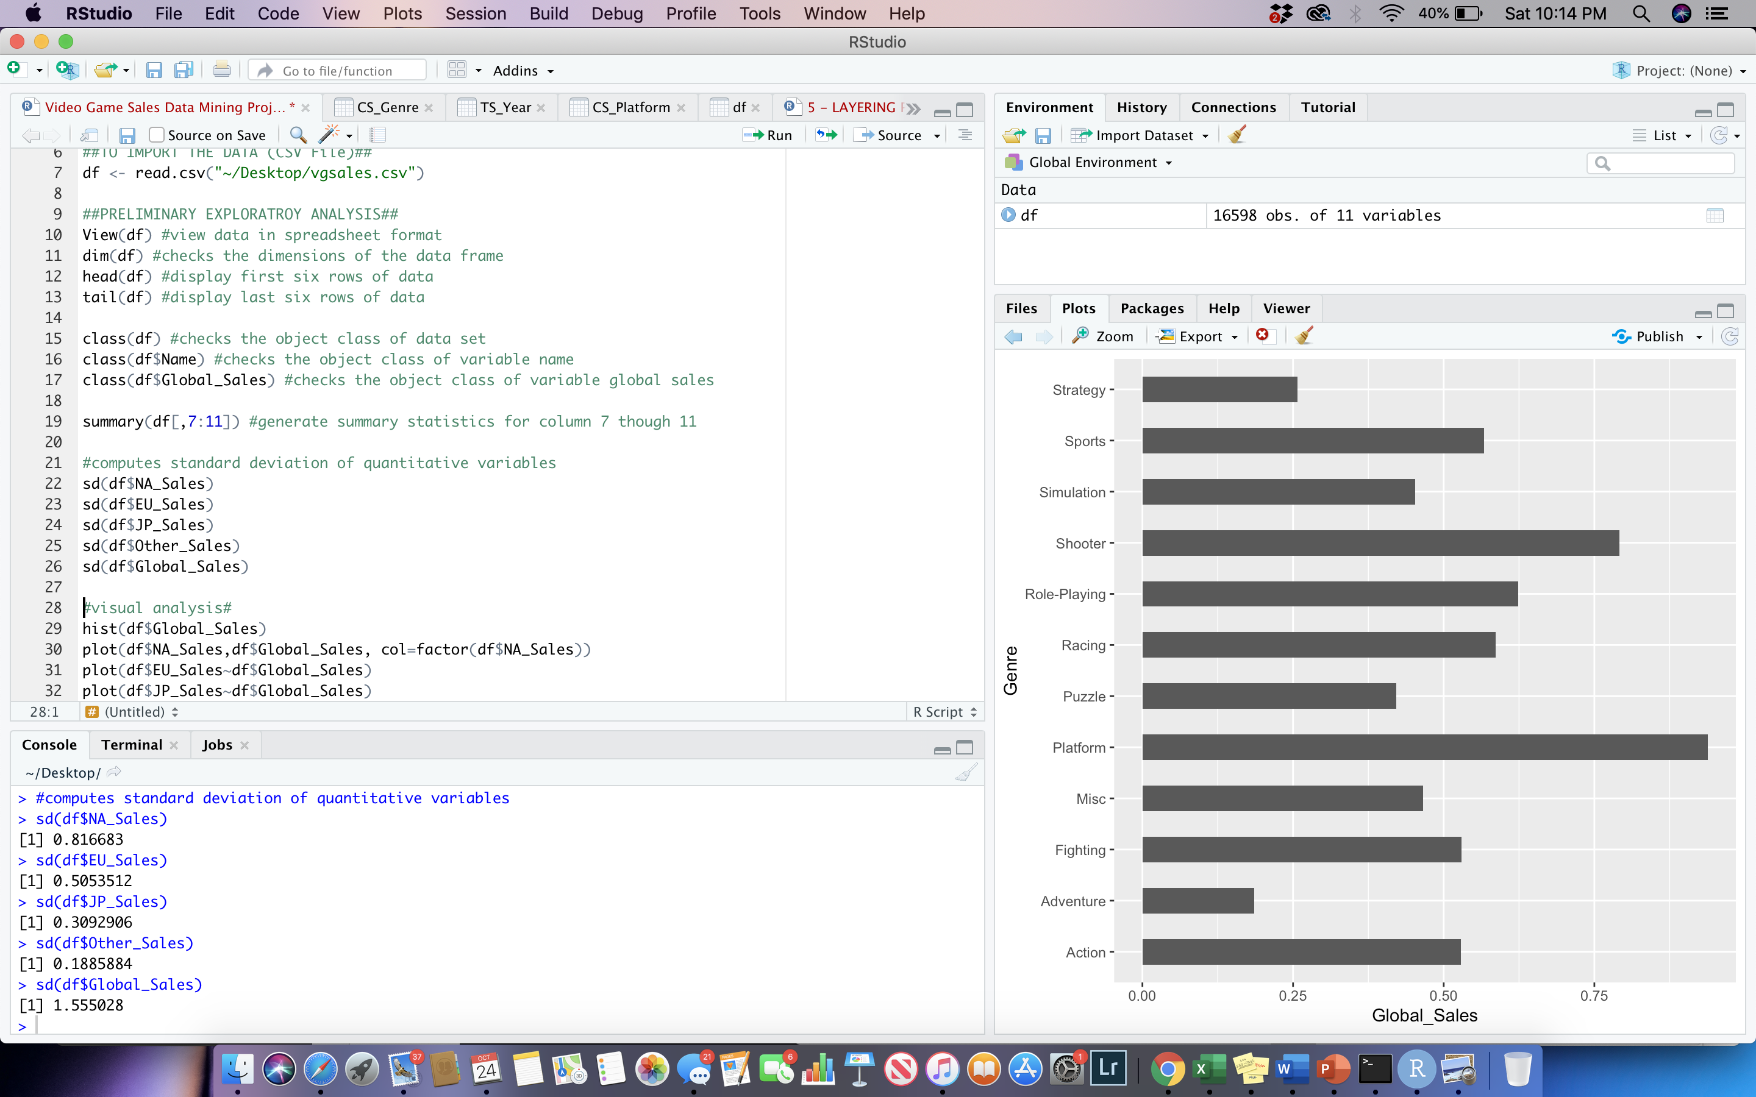

When interpreting these results, it can be noticed that the highest to lowest standard deviation is global sales, North America sales, Europe sales, Japan sales, and other sales. The variables with a higher standard deviation mean that there is greater spread of the data in relation to the mean. The variables with a low standard deviation mean’s that the data is spread closer to the mean.

**Section II**

The next part in preprocessing involves data cleaning. The data set that I am using is already cleaned for the most part, however there are minor deletion and transformation that needs to be performed. In regard to deletion I chose to eliminate the variable “rank” due to its redundancy and lack of significance. I did this by assigning the variable as NULL.

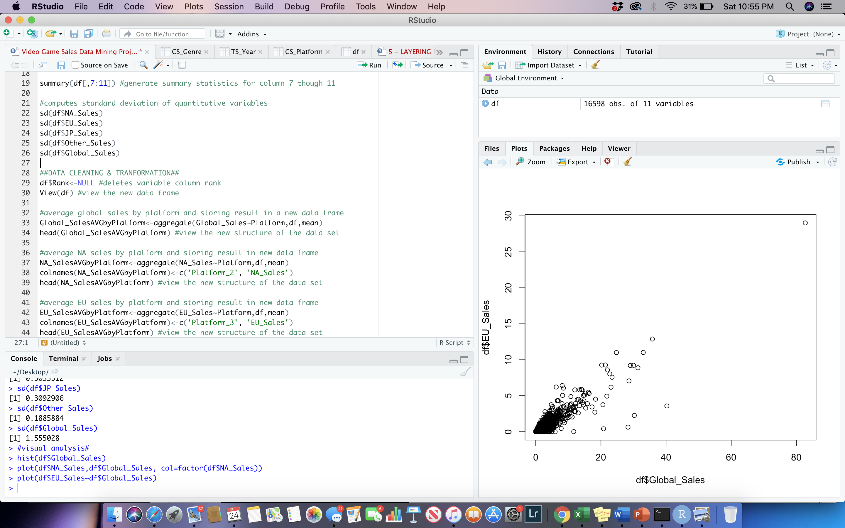

Next, I transformed the data into four separate TIDY sets to provide a clear model at how sales affect each qualitative variable. Starting with platform, I used the aggregate function to organize the average global sales for each platform within the set. I then followed by doing this to “NA_Sales”, “EU Sales”, “JP Sales”, and “Other Sales”. I combined the separate data sets revealing the average sales for each platform and deleted the extra platform columns that

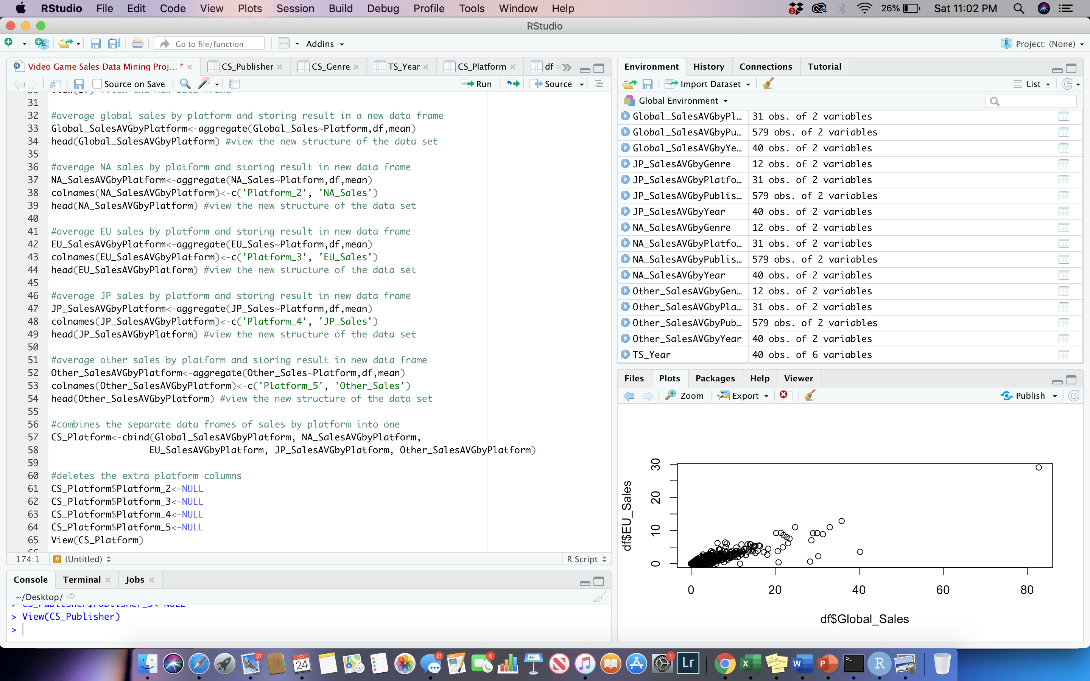

I repeated this process for genre, publisher , and year, naming the sets: CS_Platform, CS_Genre, CS_Publisher, and TS_Year. Each set is a cross sectional data set except TS_Year which is a time series. Additionally, I constructed a cross section set for name however used a shorted process by simple assigning the df set to “CS_Name” and deleting the extra columns. Here is the structure of the TIDY data sets that reveal the average sales across each variable platform, genre, publisher, and year.

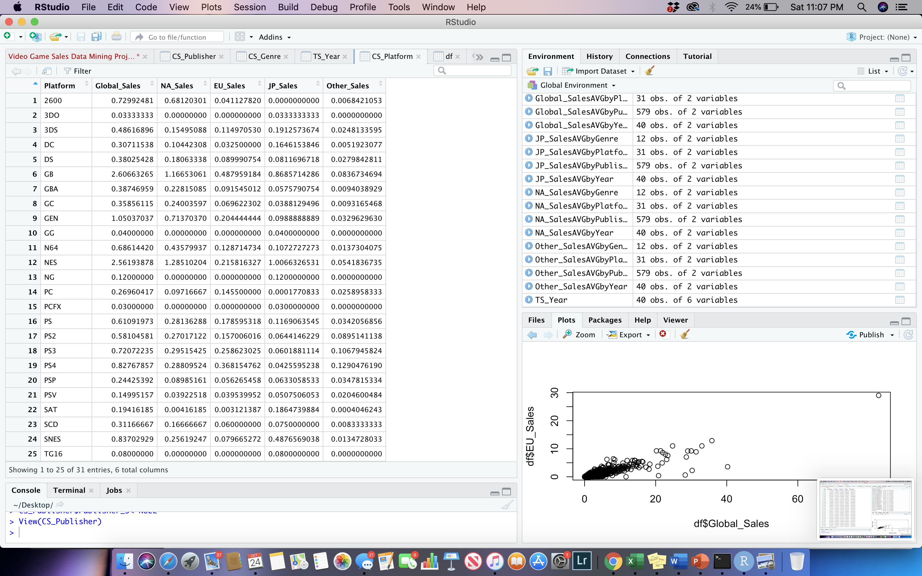

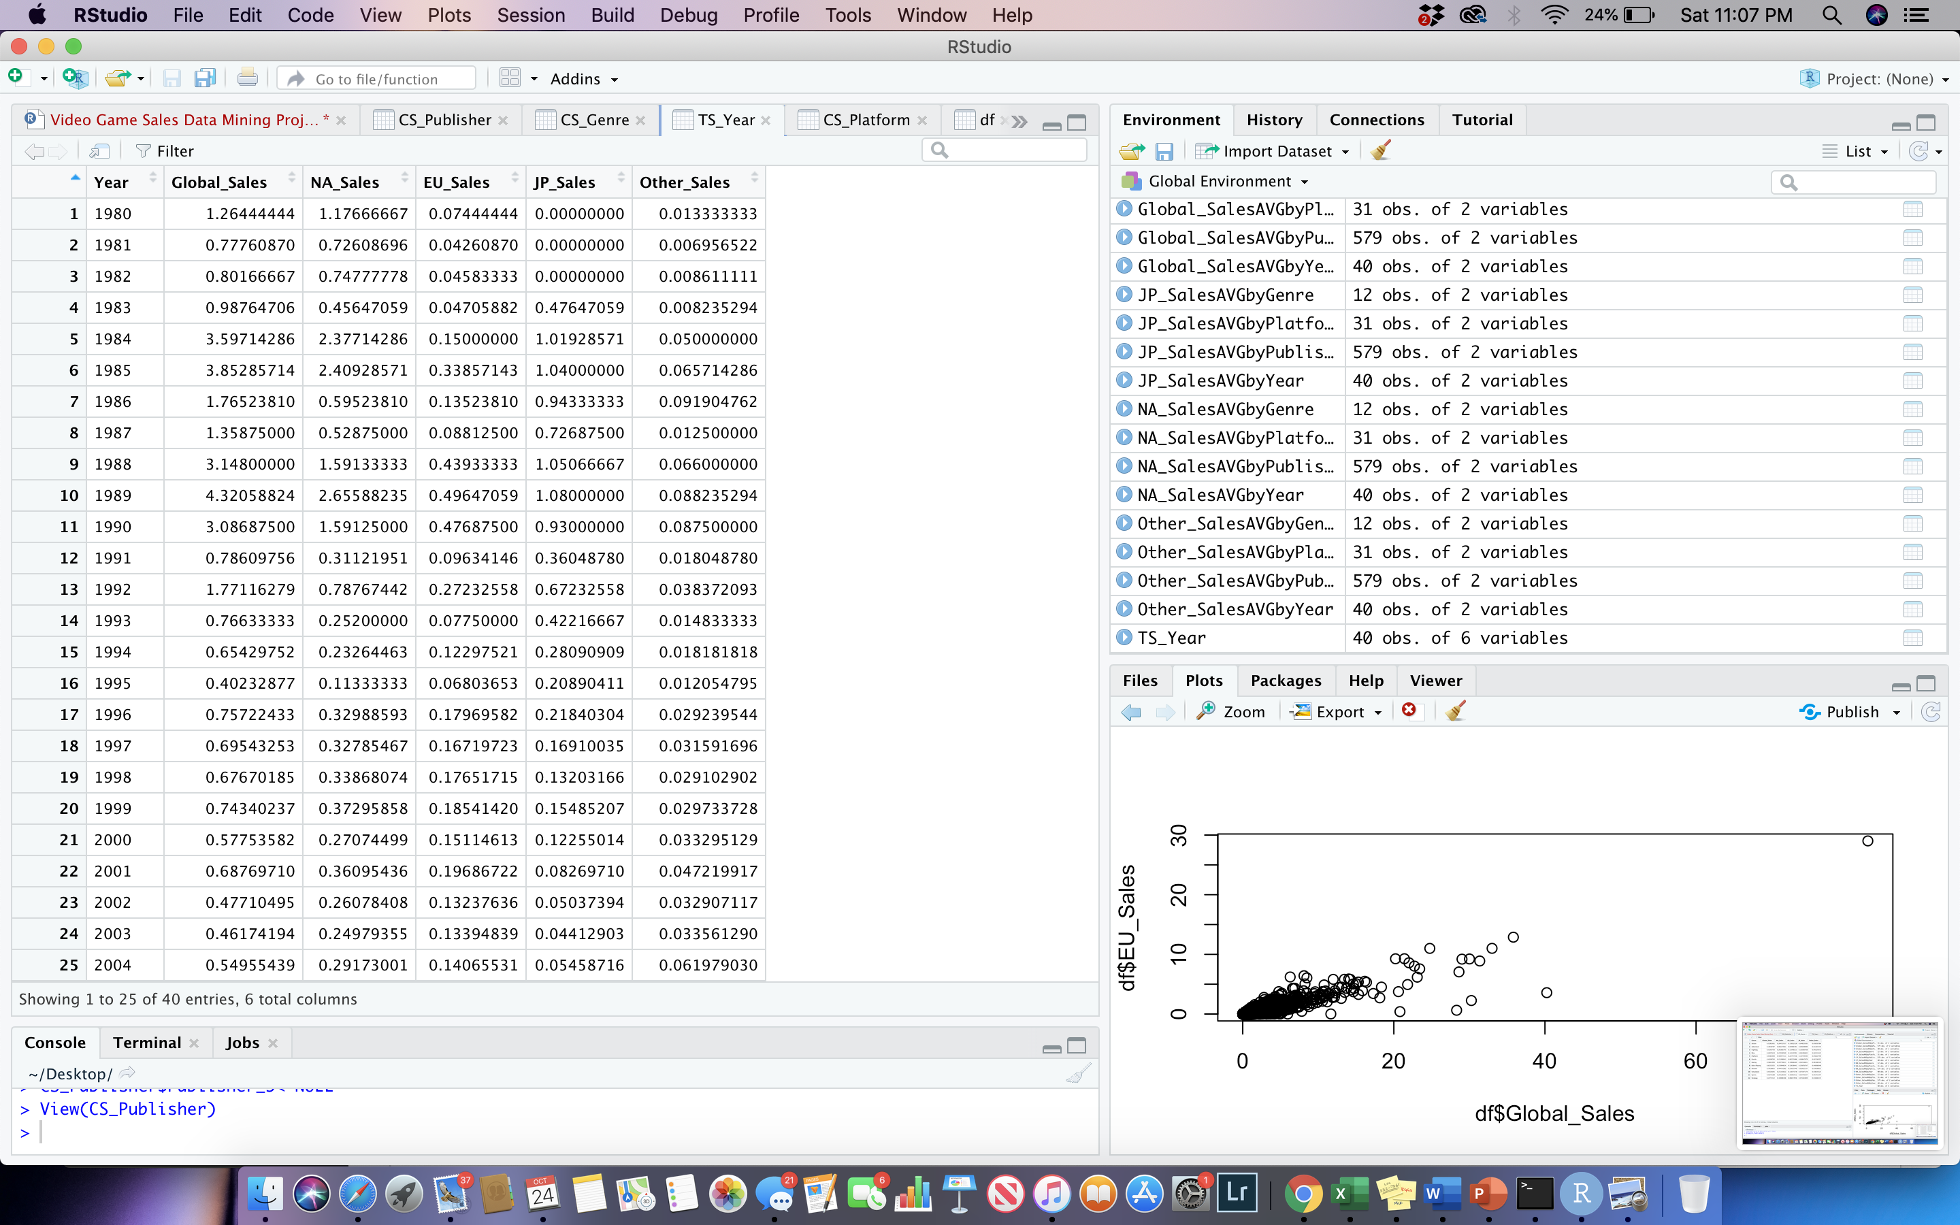

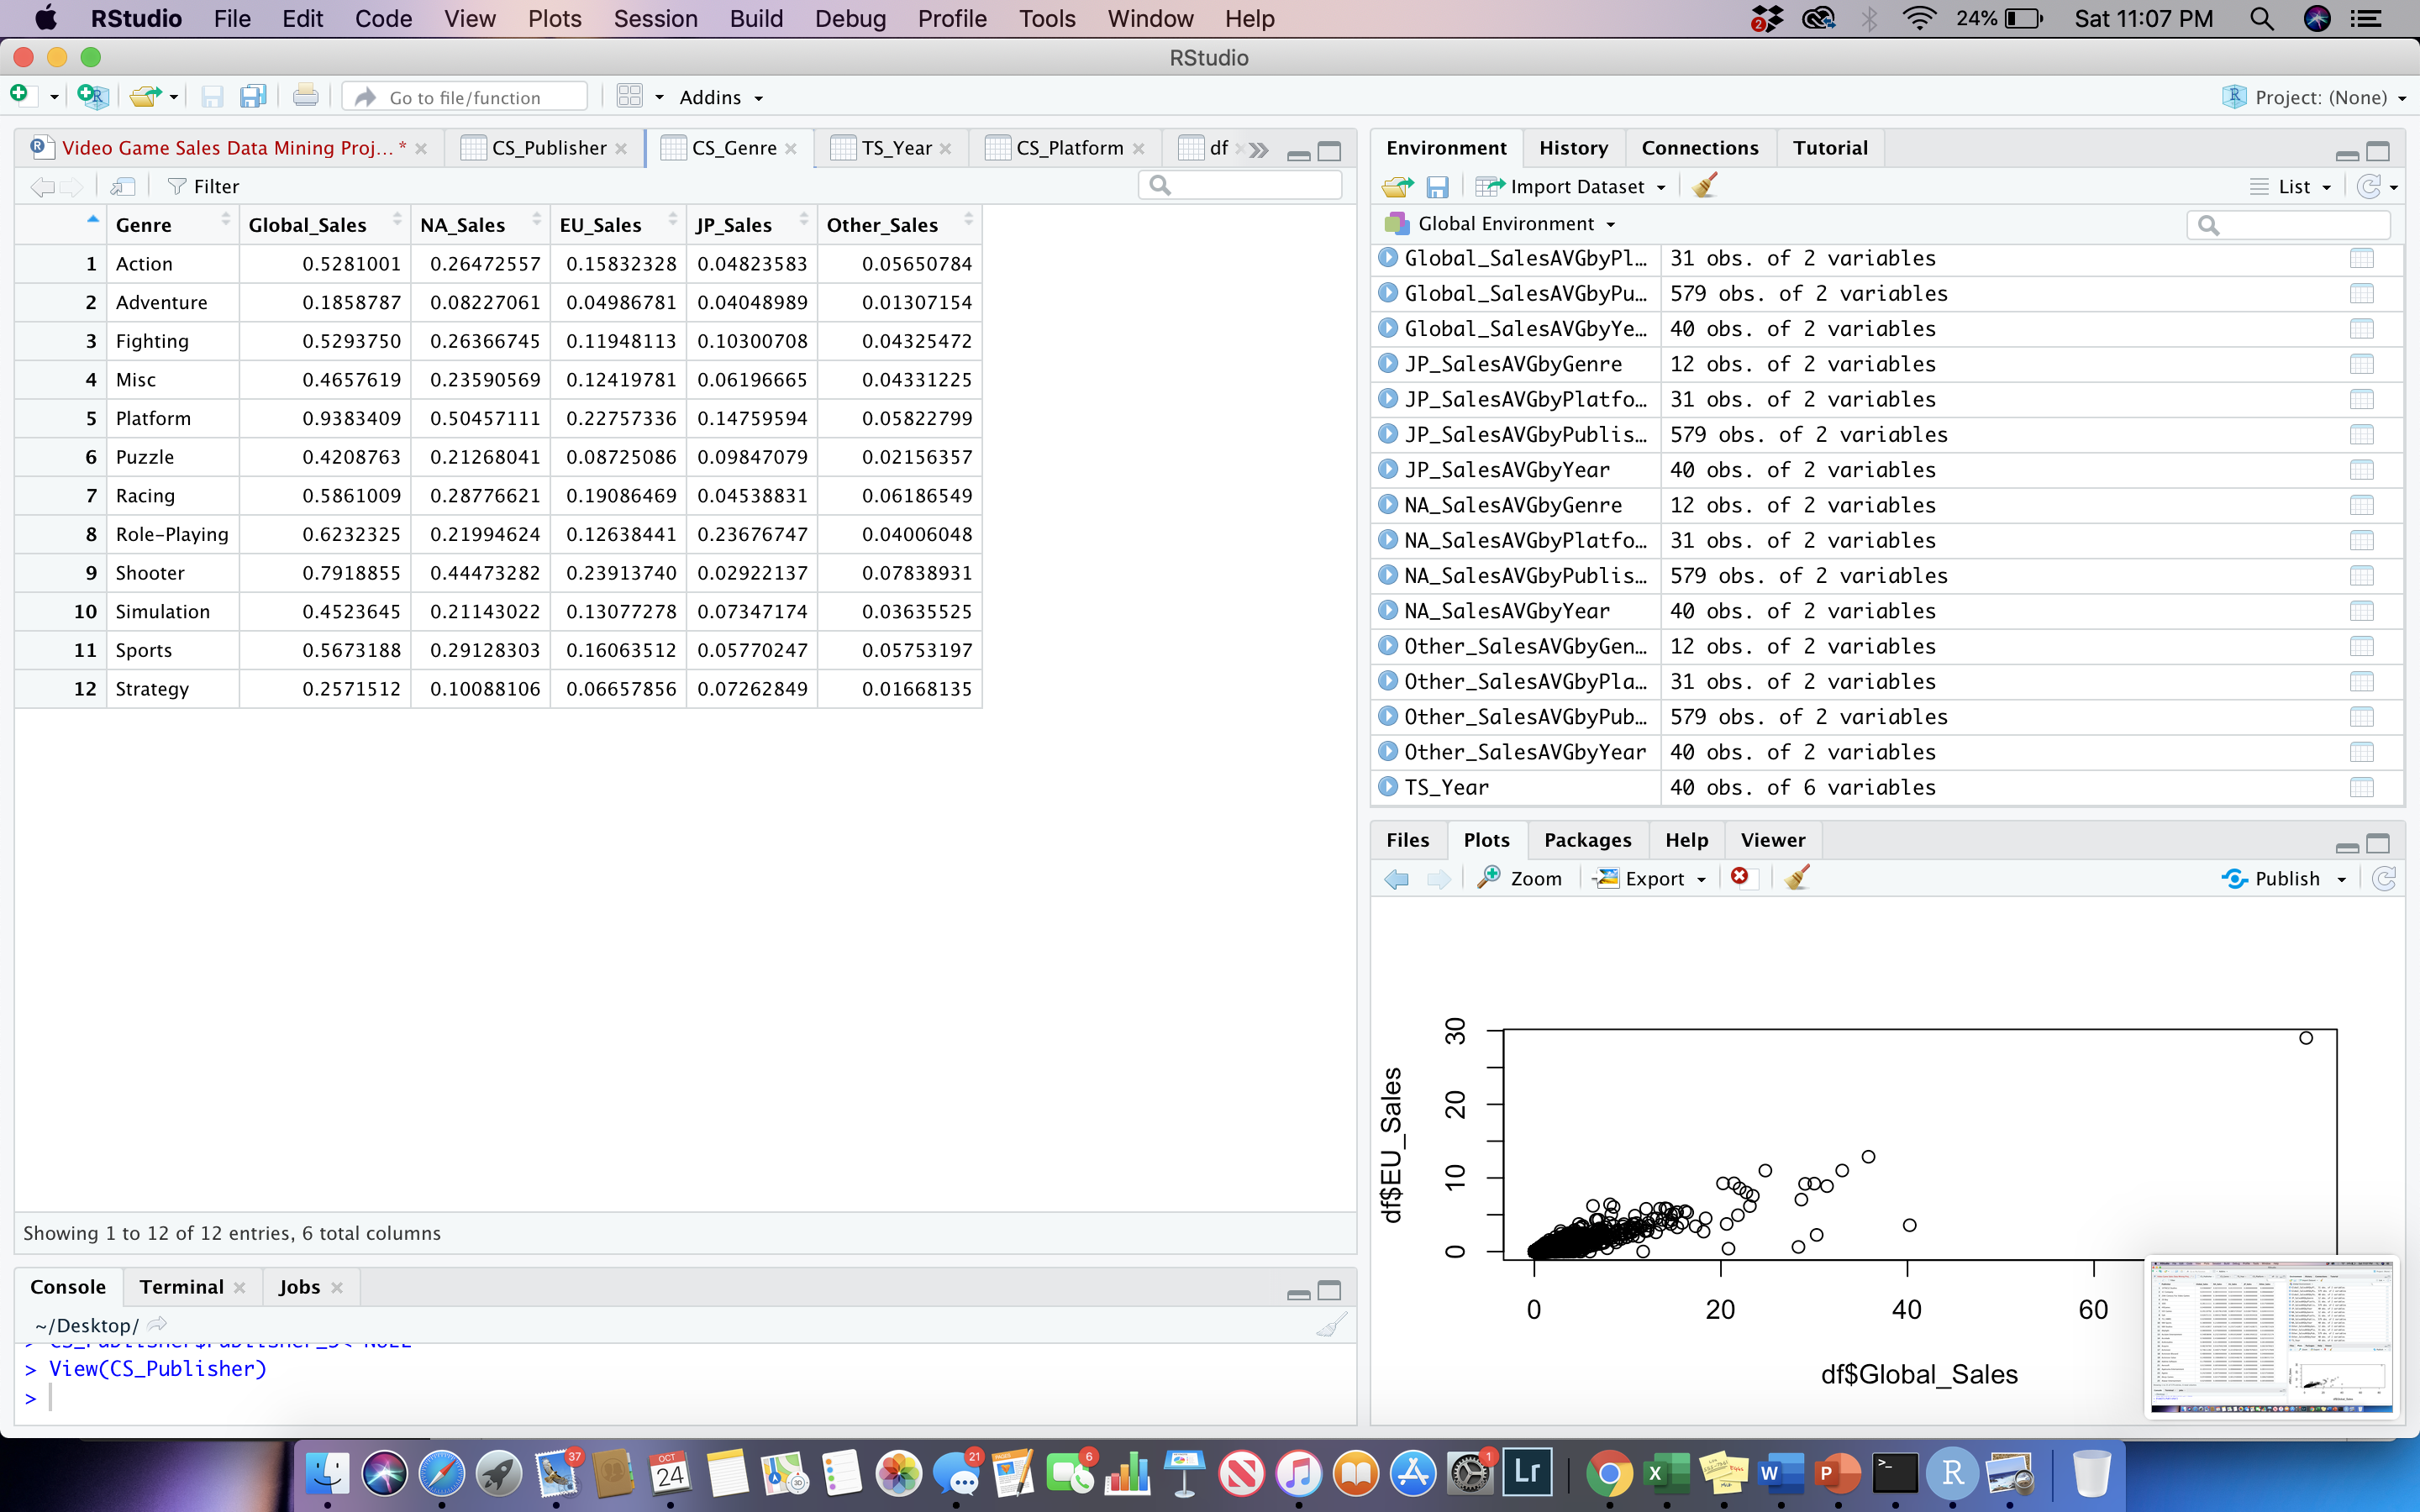

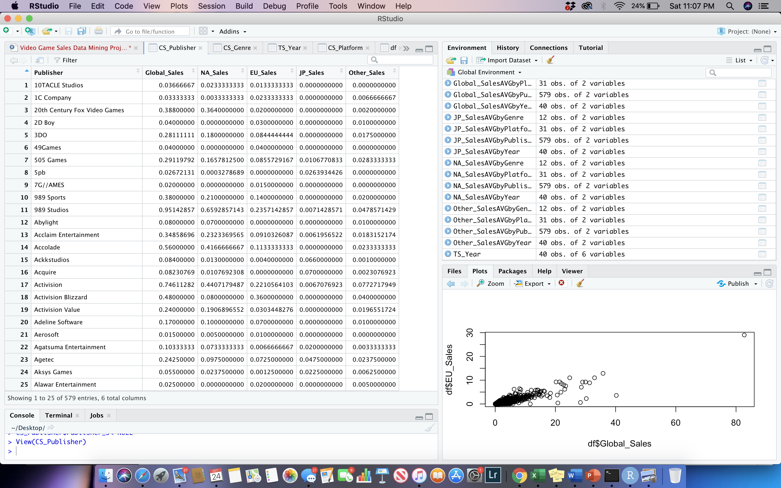

**Section III**

In the visual analysis process, I began by utilizing the ggplot2 package and loaded the library into R Studio. In my analysis’, I will observe a combination of different variables however I will focus on mainly global sales and North America sales since they have larger values and variance. First, I wanted to explore visual plots surrounding the variable, year (CS_Year). This variable represents when the games were published. My first visualization is to show the relationship between average North America Sales and average Global Sales throughout a 40-year time span. Minimum year is 1980 and maximum year is 2020. I added formatting overlays, cleaned up the plot, and was able to produce a comparison using millions as the units.

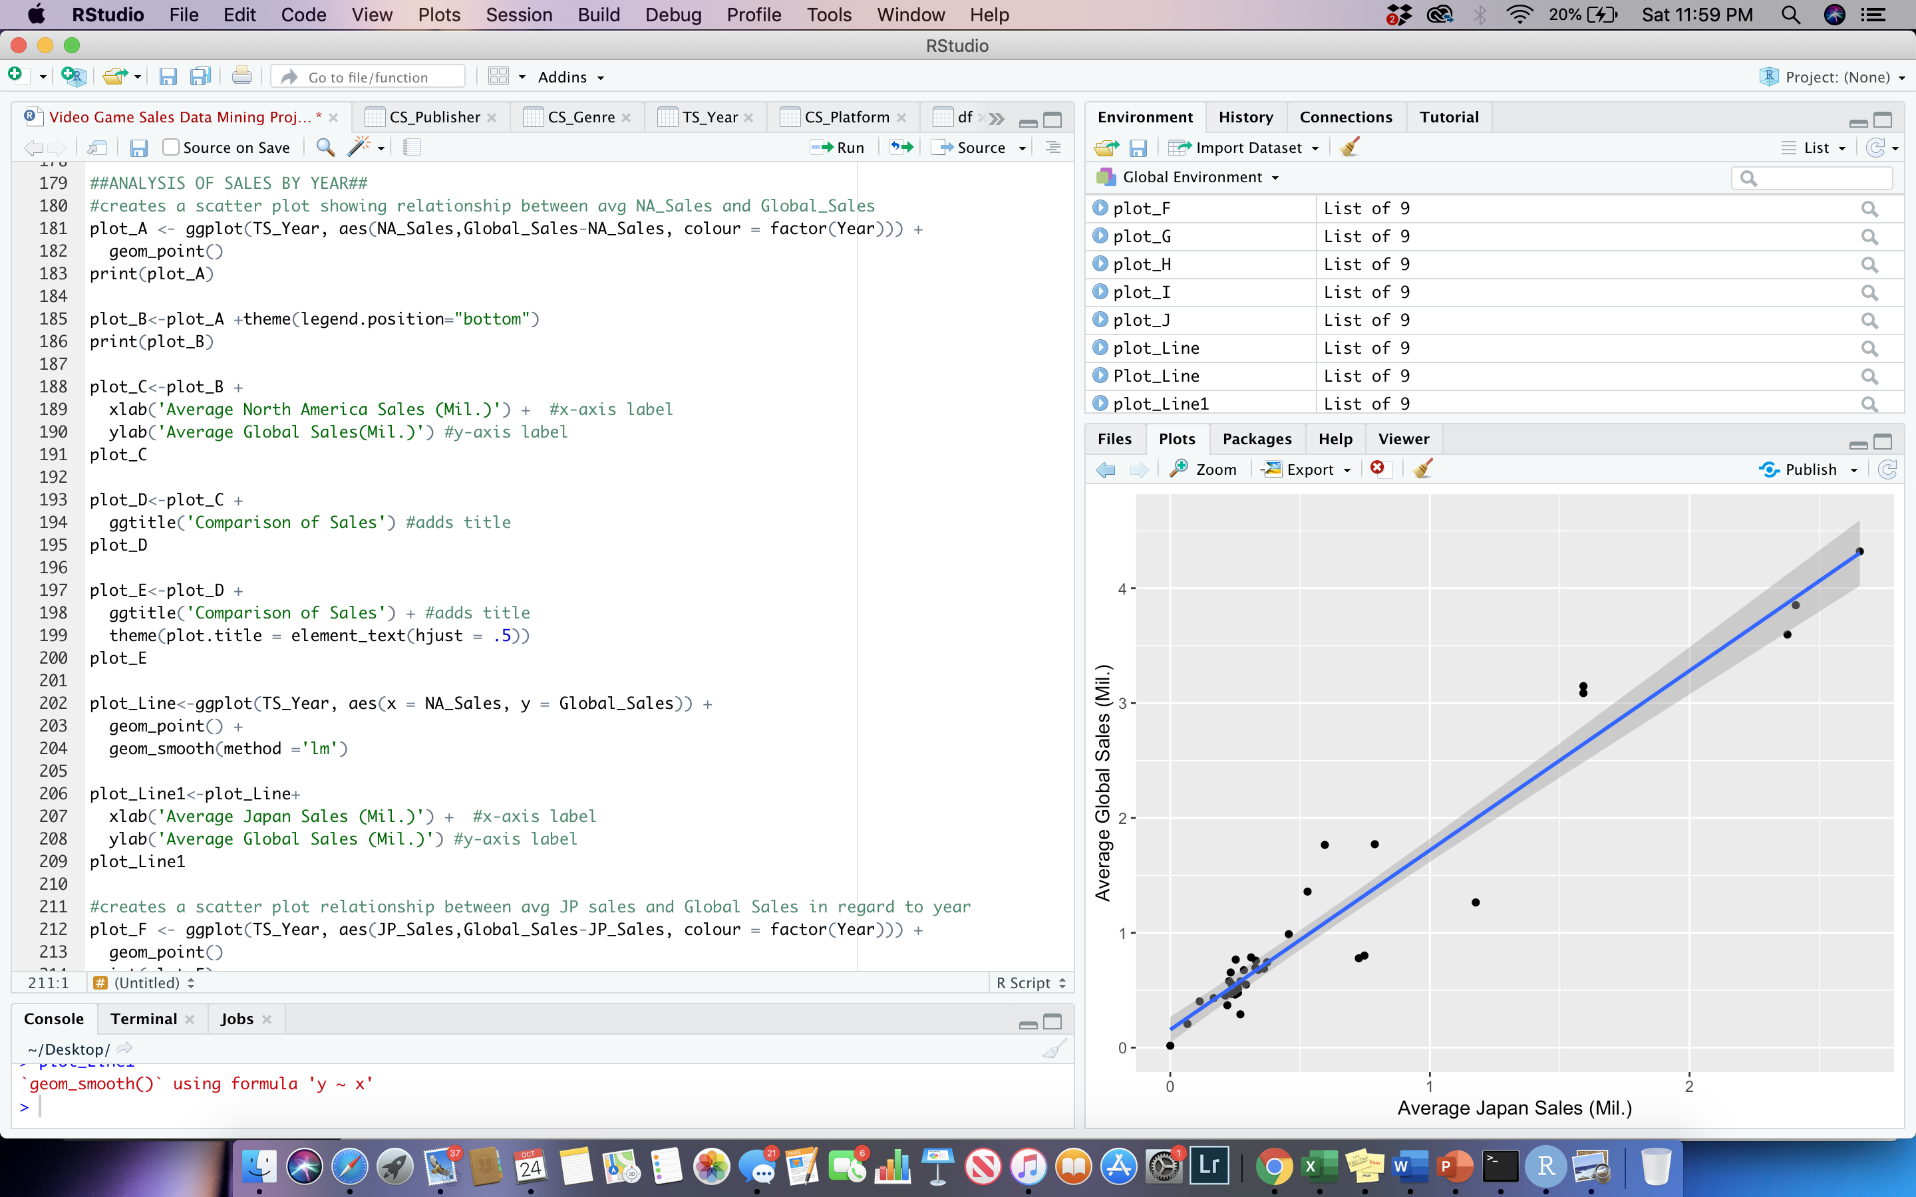

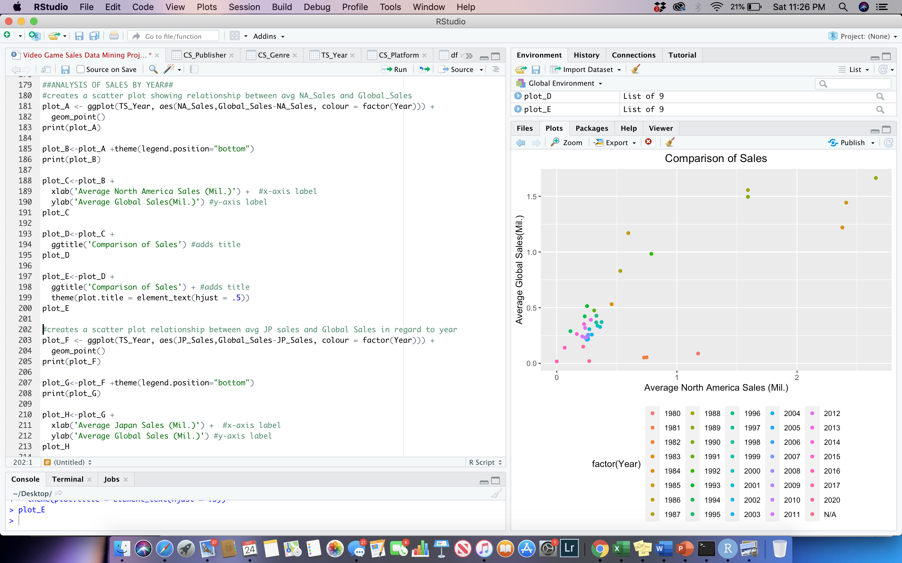

What can be observed from the graph is that some of the greatest average sales came from games that were created in the late 1980’s and 1990’s. Some of the lower sales were games produced in 2012-2020. This is probably due to the fact that these games haven’t been on the market as long as older games. Although this may be true for most older games, it can be noticed that games in the early 1980’s present much lower sales compared to games produced in the late 1980-1990’s time frame. I then created a new scatter plot displaying a line of best fit. It can be seen that there is a positive relationship between global sales and North America sales.

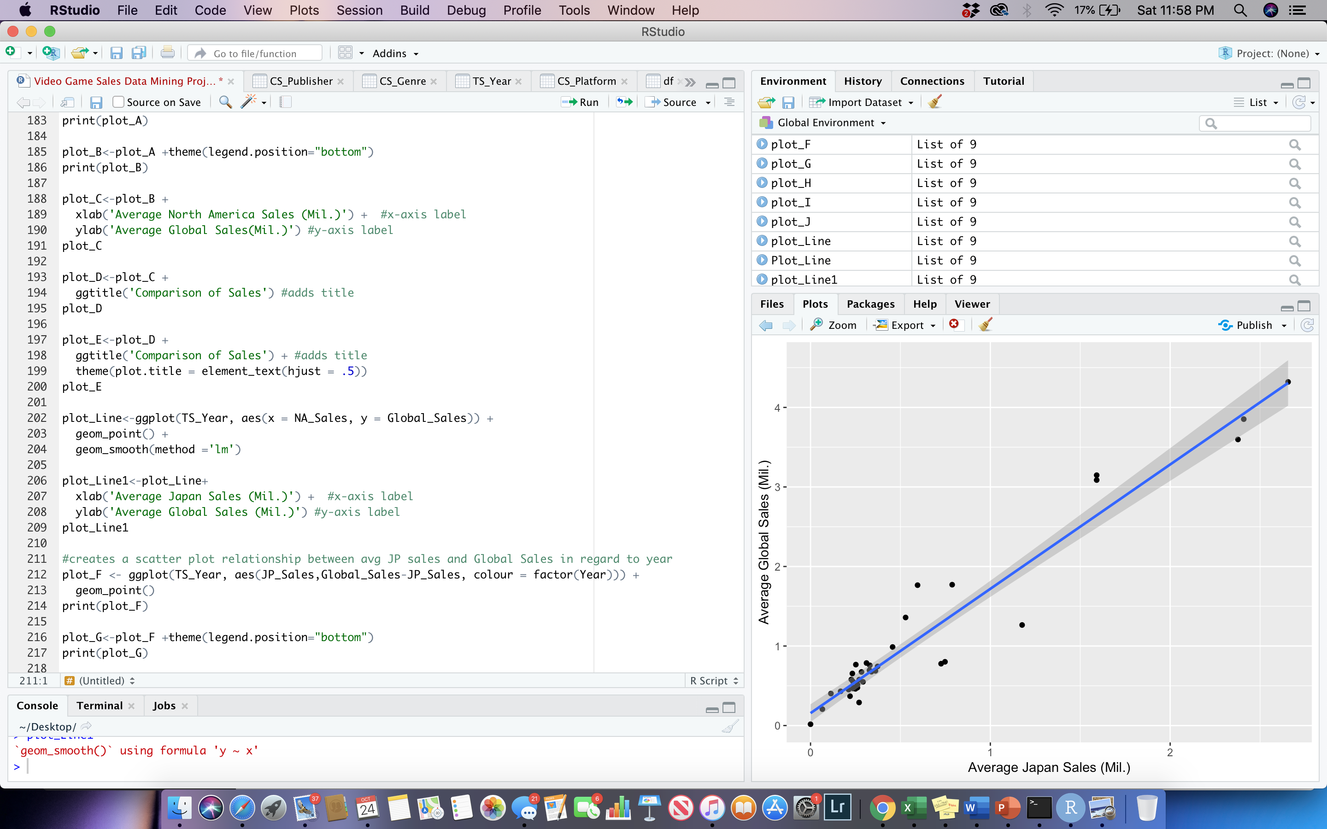

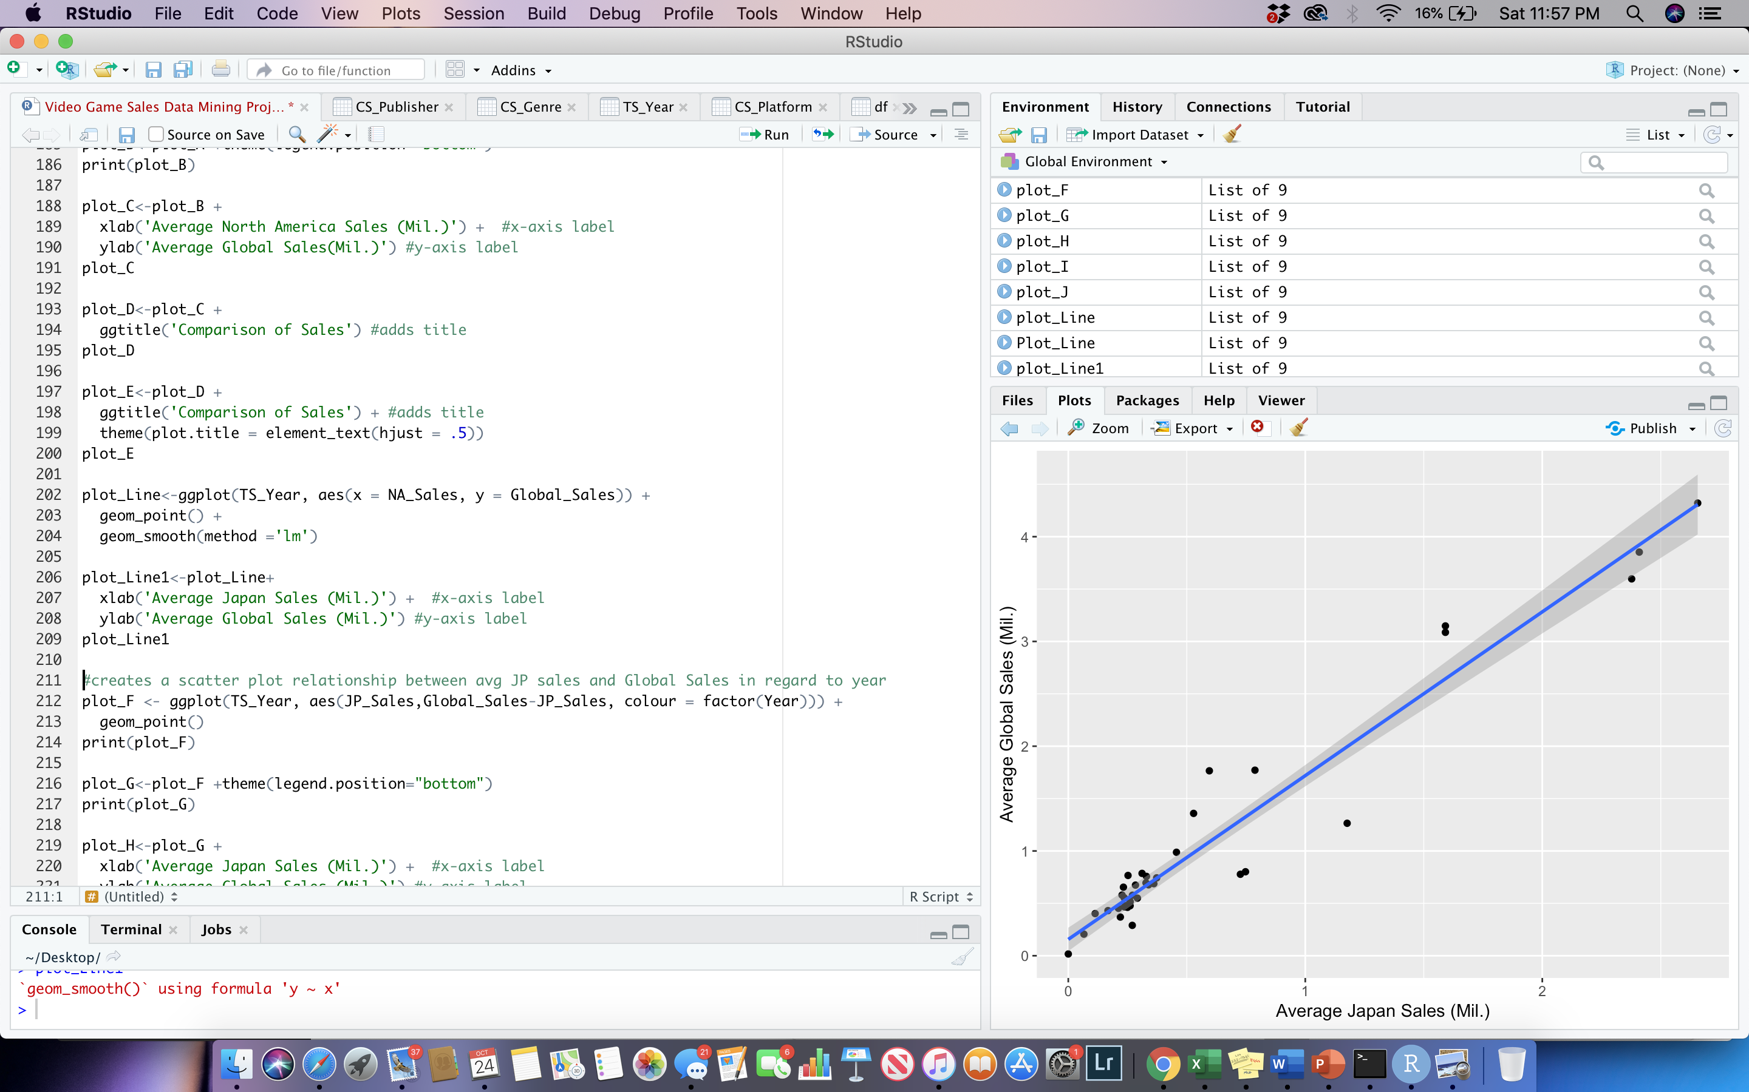

Next, I created a scatterplot using the same coding process, except analyzing the Japan Sales and Global Sales. The graph looks similar for the most part, however it can be noticed that Japan doesn’t contribute as much as North America to Global Sales. Some of the greatest sales in Japan took place in the same time period as North America: late 1980’s to 1990’s. When observing the line of best fit, there is the same positive linear relationship between japan and global sales.

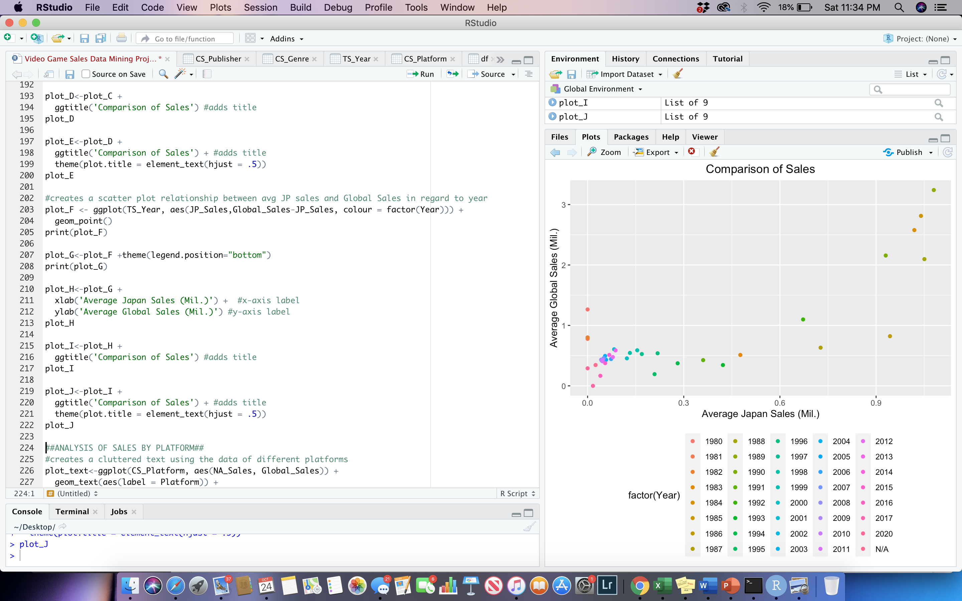

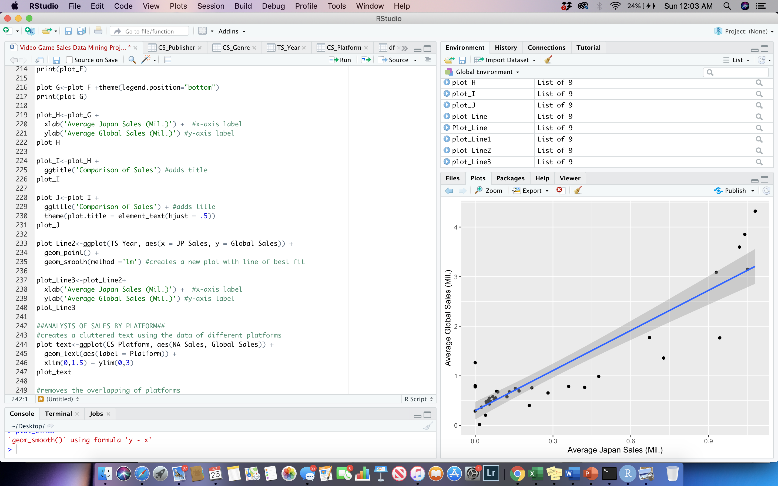

Next, I chose to analyze the average sales by platform. In this data set there are thirty-one observations. I chose to use a cluttered text graph in order to analyze which systems held the greatest average sales global and within North America. When initially creating the cluttered text graph, the text overlaps and overall appears messy. By assigning the plot with a geom_text function, I am able to clean It up and present a graph without the messy overlapping look. The function does eliminate some overlapping observations from the visual, however it still provides a clear visual at some of the greatest and lowest platforms that sell.

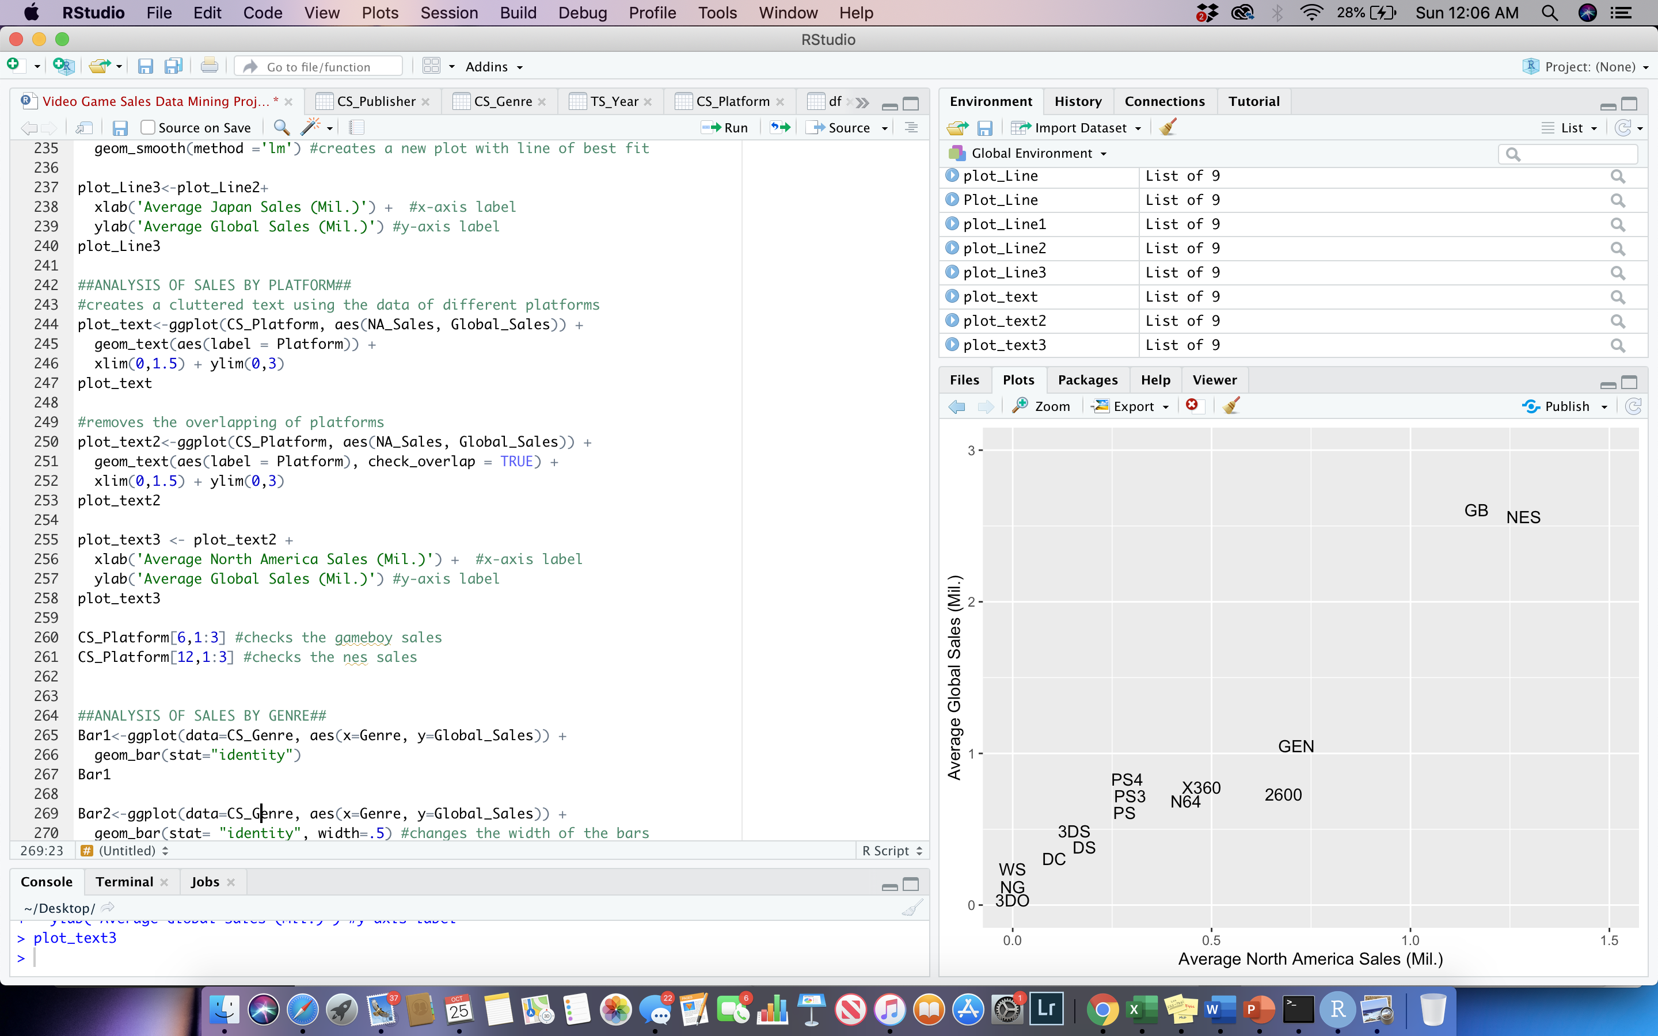

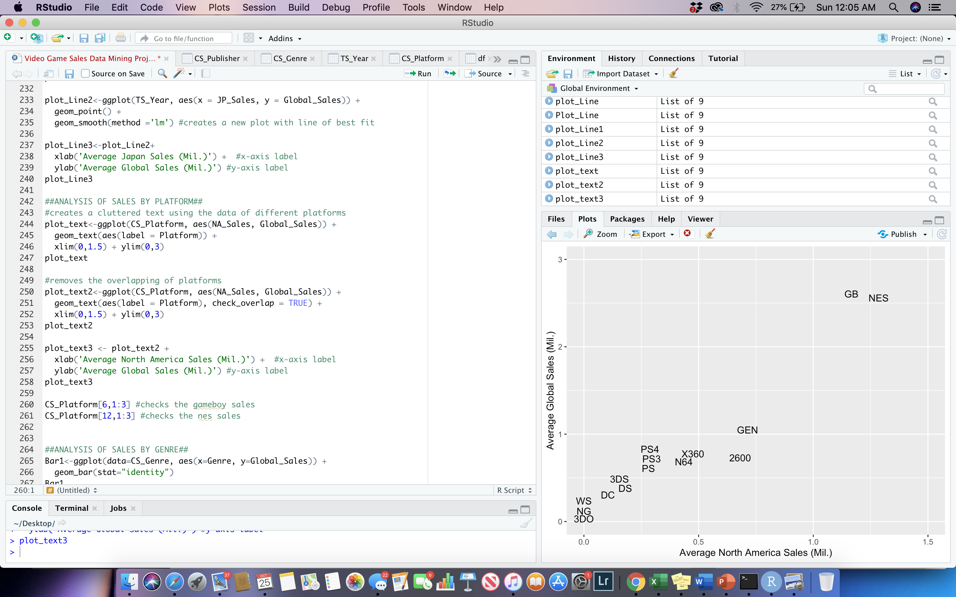

The platforms sell globally and within North America at a positive rate with two outlier that have sold more than most of the observations. GB (Gameboy) and NES (Nintendo Entertainment System) had the greatest average sales globally and within North America. Gameboy has average global sales of 2.61 million and North America sales of 1.17 million. NES has average global sales of 2.57 million and North America sales of 1.29 million. These gaming platforms have presented the two highest average sales within the minimum and maximum time period of the data set between 1980 and 2020.

Next I decided to conduct a thorough visual analysis focusing on average sales based on the genre of game (CS_Genre). In this section I focused on global sales, North America sales, Japan sales, and Europe sales in order to gain a greater understanding of which types of games dominate dependent on region. Being able to recognize which types of games produced the most sales in the past can provide developer with useful information on what direction to take in terms of future development. The bar chart itself is cleaned and positioned horizontally to provide an aesthetically pleasing visualization at the greatest selling genres: 1) Platform, 2) Shooting, and 3) Sports. Next I decided to dig deeper into what genres dominate the other variables or regions. To approach this, I constructed separate pie charts for North America sales, Japan Sales, and Europe Sales.

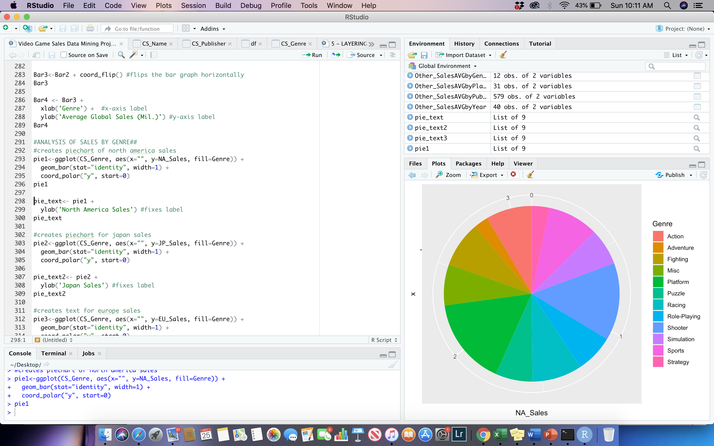

What can be noticed in regard to North America is that the two greatest selling genres had been shooter and platform. In regard to Japan it was heavily role playing and then platform. For Europe it was shooter and platform as well. Overall, it can be realized that platform shares a great number of regional shares while also still dominating global sales.

The last analysis conducted follows a histogram texting the skewness of the data. I constructed a histogram using the hist function in regard to global sales within the cross-sectional genre data (CS_Genre). I then added a normal density curve and then conducted a hypothesis text for normality. At first sight of the histogram it, appears to be normally distributed. When applying the normal density curve, it appears to be normally distributed at well. By performing the jarque beta hypothesis test for normality, R studio is able to calculate the p-value for the user by calculating it within the system. Essentially, the p value has to be smaller than 5% for us to reject the null hypothesis which is that the data is normally distributed. The p-value calculated in this context was 0.9231, which means we fail to reject the null hypothesis. Therefore, it is safe to say that the set is normally distributed.

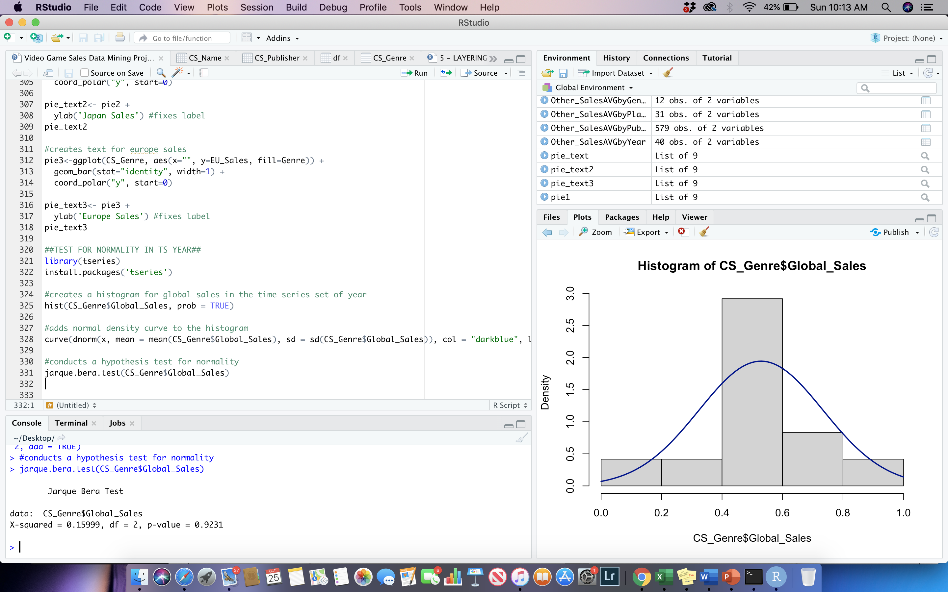

**Section IIII**

In summary, this analysis has followed the analytical pipeline by collecting data, preliminary analysis, cleaning and transforming, and exploratory visual analysis. The video game sales data itself provided compelling information on the different genres, platforms, years, and publishers that sold dependent on North America, Japan, Europe, other Countries, and globally. Some key takeaways regarding genre is that platform and shooting seem to hold the most average sales within the 40 years’ time frame that exists within this data set. When analyzing platform, the Gameboy and NES system holds some of the greatest sales within the set. In regard to years, some of the greatest average sales involved games produced in the late 1980’s through 1990’s. Lastly, the top three selling games were Wii sports, Super Mario Bros, and Mario Kart Wii.